## **Editing Special Patrols**

1. While in the editor, click the Edit Button to begin adding or modifying a special patrol:

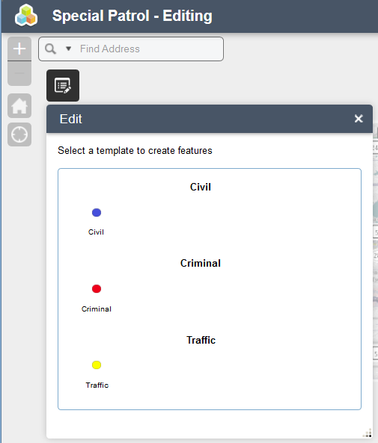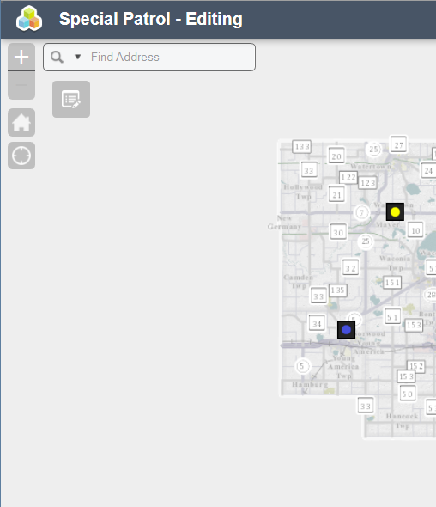

1. 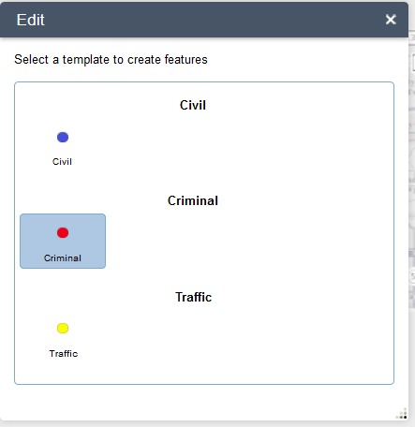To add a point, select one from the template and click on the map. Enter the start and end dates of the patrol as well as a description of the patrol

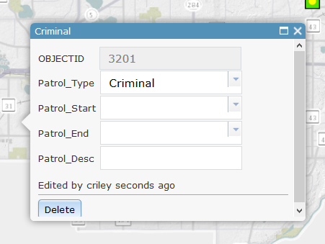

1. To edit an existing point, simply click the Edit Button to activate it, then click on the special patrol on the map and edit the dates, description, type or description.
2. When done editing a special patrol, simply click the ‘X’ to close out the window. You can delete an existing point by clicking the ‘Delete’ button:

